**Designing For Virtual Environments**

**Group Project**

**VR Shoe Store**

Liam Aspell – 17300046

Student Name – Student Number

Student Name – Student Number

Student Name – Student Number

Student Name – Student Number

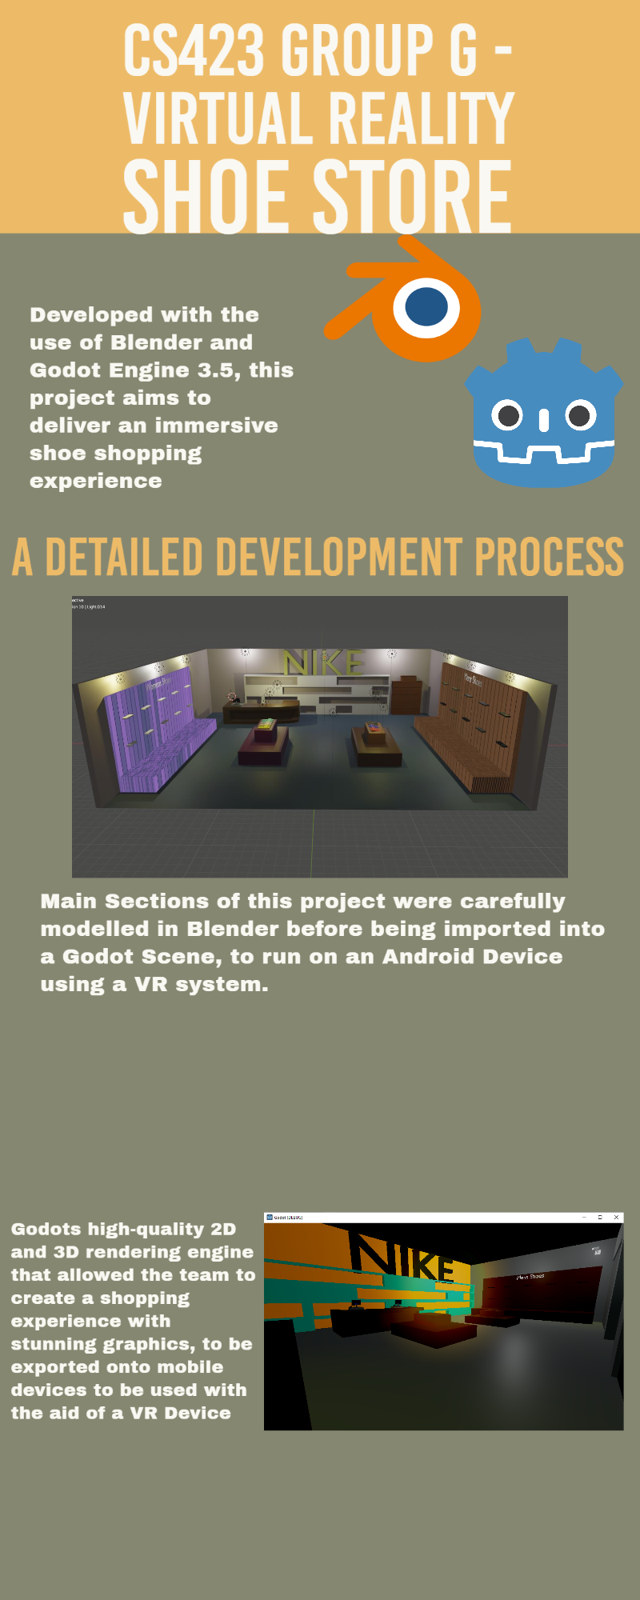**Infographic**

Eoin Section

Ahmed Section

Syeds Section

**Some extra models to create detail.**

To combine the tasks of practicing modelling in blender to ‘warm up’ for the project, as well as creating detail in the shop scene, a selection of background items was modelled from scratch in blender. Two of these items were the lampposts that are present near the building, and the CCTV cameras which are hanging on the walls of the shopfloor. Models such as these help to create realism to boost levels of immersion.

**Designing the Shop’s Shoe Display Areas.**

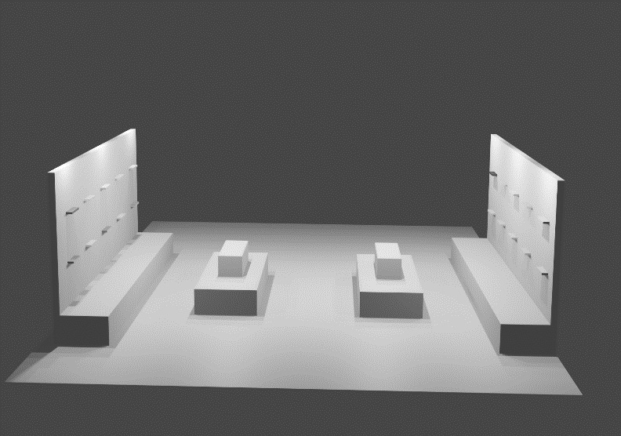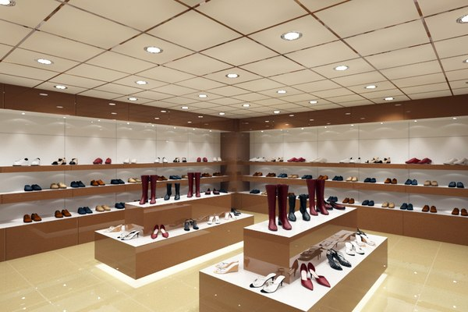The design of the shop was inspired largely by shop designs found online. One such inspiration is contained in the figure below. A scene was developed containing a shoe display wall and a display island. The approach is to have a section both for women and men’s shoes, so the symmetry seen in the model figure below will be split men and women’s sections symmetrically. The wall display units have small shoe holders typically seen in many shoe stores.

**Extra Feature – Shop Music.**

The addition of shop music into the VR environment helps to set the tone within the scene, which enhances the users overall experience interacting with the environment. The music in this scene enhances immersion by stimulating the sense of hearing, which is an important feature of virtual environments. Royalty free music was sourced and placed in the environment using an AudioStreamPlayer node. Overall, music can significantly impact the atmosphere and experience of the shop environment, creating a more engaging and memorable experience for visitors.

Dara Section